Lesson Plan Format Guidelines:

Paper Size: A4 (8.3 x 11.7 in / 21.0 x 29.7 cm); or
Letter (8.5 x 11.0 in / 21.6 x 27.9 cm) (US’ standard)
Margin: Top – 1 in / 2.54 cm Bottom – 0.5 in / 1.27 cm
Left – 0.5 in / 1.27 cm Right – 0.5 in / 1.27 cm

Front Size: Mark Pro & Mark Pro Medium
Title (e.g. Lesson 4 Visualizing the Global Warming) – 18 points Mark Pro Medium, Bold Added
Heading (e.g. Objectives/Activities/Section 1 Introduction/…) – 14 points Mark Pro Medium, Bold Added
Sub-heading (e.g. Procedure/Step 1/…; headings within the main content) – 11 points Mark Pro Medium, Bold Added
Main content – 11 points Mark Pro
Bold added for emphasis when necessary
Indentation: not for the main content
Line Spacing: 1.5 lines (or 22 points at least)

Spelling and punctuation:
American English and rules for North America
British English and rules for the Commonwealth, and the EU

Use endnotes rather than footnotes
Works cited: Harvard reference, cf. https://www.imperial.ac.uk/admin-services/library/learning-support/reference-management/harvard-style/

Delivery: PDF


Lesson 3:
Listen to mBot2

Subject: STEAM Grade(s): 5th and up
Duration: 45 Minutes Difficulty: Beginner

 Lesson Objectives
By the end of the lesson, students will be able to:
- Recognize and use the code blocks for controlling the speaker and microphone
- Build your own computer program in mBlock to make the mBot2 record sound and play it back
- Run multiple programming tasks side by side in a computer program

Overview
Robots can often talk. Take, for example, the vacuum cleaner robot that uses a voice message to let you know its battery is low. Or a toy robot that sings a song. The mBot2 can also produce and record sound. It has a microphone and speaker for that. With the microphone, the mBot2 records sound and the speaker plays back the recorded sound.

 Focus
By the end of this lesson, students will know:
- How to make use of the speaker in coding and robotics
- How to record and play back sound
- How to run multiple programming tasks side by side

 Pre-lesson Checklist
What do you need?
- PC or laptop (with USB output) with the mBlock software installed, the web version (also for ChromeBook), or a tablet with the mBlock app installed
- The mBot2 with a CyberPi
- A USB-C cable or Makeblock Bluetooth dongle

 Lesson plan
This lesson consists of four steps and takes a total of 45 minutes.
Duration | Contents
5 minutes | 1. Warming up  - Speakers in everyday life  - How does the speaker work?
10 minutes | 2. Hands-on  - Getting acquainted with the different code blocks of the speaker and microphone.  - Reproduce, test and extend some programming examples of the speaker and microphone.
25 minutes | 3. Trying out  - Writing your own program for the robot.
5 minutes | 4. Wrap-up  - Showtime: show what you did with your robot in a fun, short movie for later discussion.  - If your teacher allows, share the end result on social media with the hashtag #mBot2speaker  - Reflection: What are you most proud of? What would you like to improve about your robot?

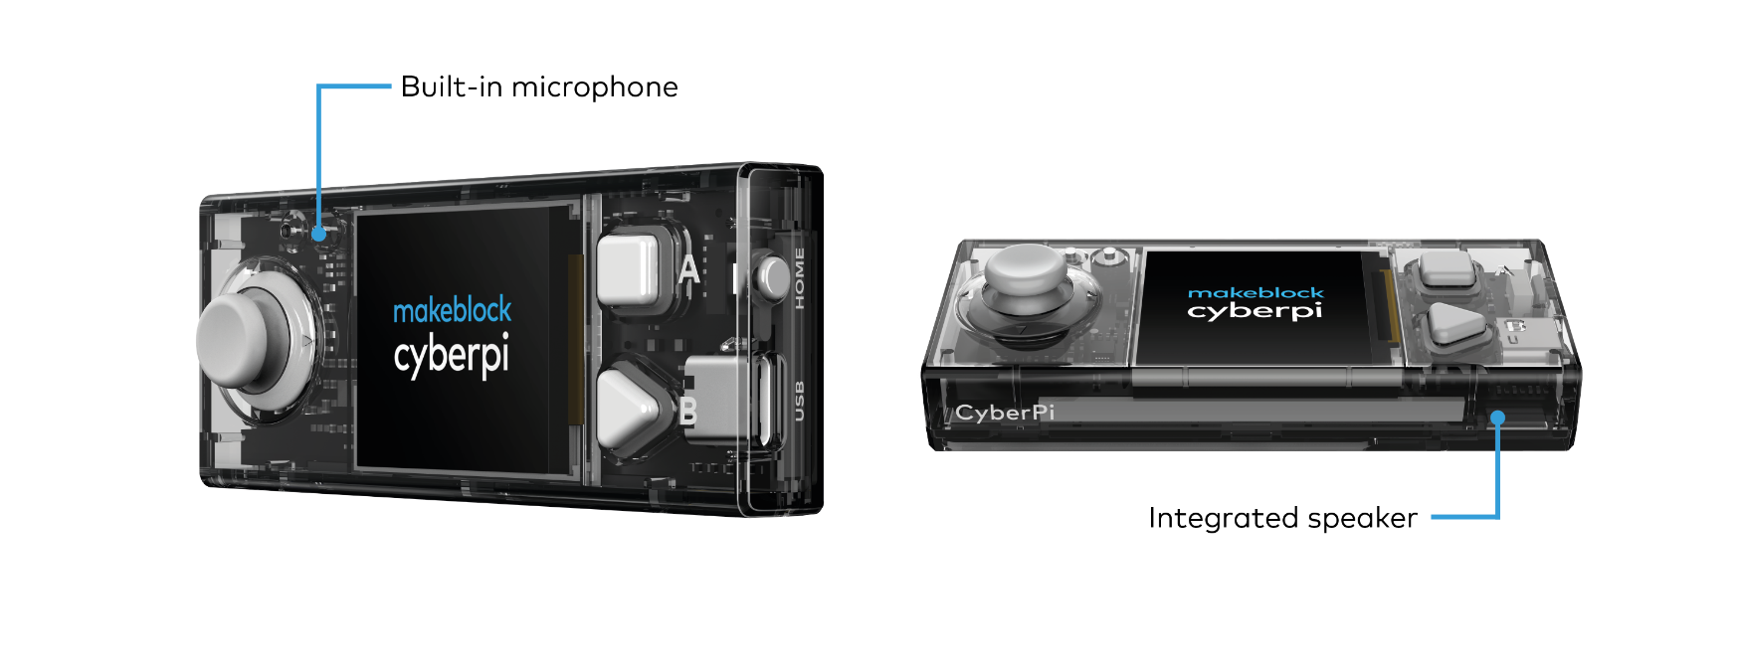
 Activities
1. Warming up
(5 min)
Step 1: Warming up
This step consists of two parts:
- Speakers in everyday life
- How does the speaker work?

1. Speakers in everyday life
Speakers are used all around you in everyday life. You will find large speaker systems in theaters, concert halls and event halls. These speakers are used to amplify the sound for a large group of people. Smaller speaker systems are found in appliances, such as televisions, musical instruments, and smartphones. Can you and the classmates in your group think of more applications?

2. How does the speaker work?
The purpose of a speaker is to produce sound. Speakers convert electromagnetic waves into sound waves for this purpose. Next to its main purpose, a speaker can actually convert sound waves back to electromagnetic waves, too. Microphones are devices that use the same principle, but are optimized for the purpose of converting sound waves to electrical signals.

On the mBot2 there is a speaker and a microphone. The microphone is on the top left of the CyberPi. The speaker is on the front of the CyberPi. With the microphone you can record sounds. These sounds can be played back later with the speaker.

By using the microphone and the speaker in combination with the other sensors of the mBot2 you can, for example, have your own recorded text played back at a specific time. For example, think of a public bus which tells you which stop you are almost at. There are countless other possibilities for using the microphone and speaker. Together with the classmates from your group, think of more examples where the mBot2 can make good use of the speaker and microphone.
2. Hands-on
(10 min)
Step 2: Hands-on
This step consists of two parts:
- Getting acquainted with the different code blocks for the speaker and microphone.
- Reproduce, test and extend some programming examples of the speaker.

1. Getting to know the different code blocks for the speaker and microphone
In mBlock 5, there are several code blocks that you can use to program the speaker and the microphone. You will find these code blocks in the 'Audio' category of the block area in mBlock. These code blocks are purple.
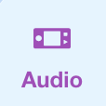
In the table below you will see some of these code blocks to program the speaker and microphone.

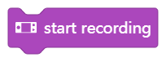
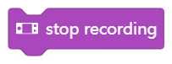
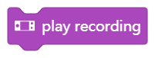
Code block:

When recording and playing back a sound, you actually always use three code blocks. With the code block 'Start recording' you let CyberPi start recording a sound. The electrical signal from the microphone is stored in the memory of the CyberPi, and the recording automatically stops after 10 seconds. You can also indicate when the recording should stop. This is done with the code block 'Stop recording'. The recorded sound is temporarily stored in the memory of the CyberPi. Do you switch off the mBot2? Then the recorded sound is lost. Playback of the recorded sound is controlled by the 'Play recording' code block.
In the programming example below, when you press button A, CyberPi starts recording. After 3 seconds the recording stops. When you press button B, you hear what was recorded. By using two event blocks, two programming tasks can run independently from each other without the need for a main loop.
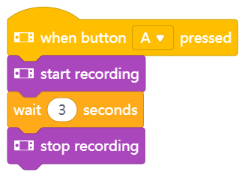
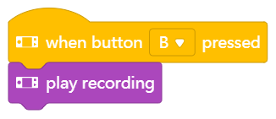

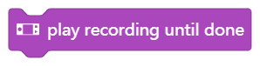
Code block:

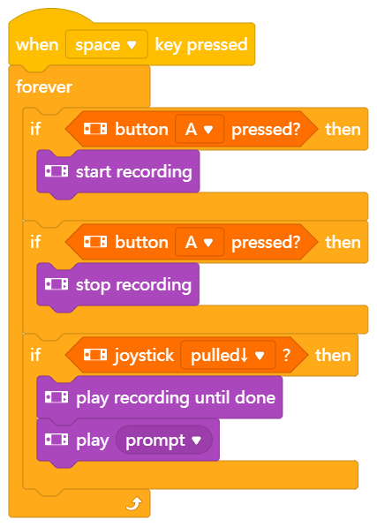
You just learned how to playback a recorded sound. With this code block you make sure that the sound recorded by the microphone is played all the way through. This means that the execution of further blocks is blocked until this one is finished. After the sound is finished you can make the mBot2 do something else. For example, make a certain sound so you know the recording is finished.

In the programming example to the right, the CyberPi starts recording when you press button A. If you press button B, the recording stops. If you move the joystick down, you will hear what the mBot2 recorded. After the entire recording ends, you will hear a "prompt" sound. The code blocks in this example are placed in a so-called loop structure. This ensures that the input from the buttons and joystick are continuously monitored.

2. Reproducing, testing and extending some programming examples from the speaker
In the table above, each code block of the speaker is accompanied by a programming example. You are going to recreate these programming examples in mBlock and test them. Think of one extension to a programming example. Test the programming examples and your own extension in live mode.

3. Trying out
(25 min)
Step 3: Trying it out
You've already learned a lot about the speaker and microphone on the mBot2. You are now going to work on them by yourself. You are also going to use the ultrasonic sensor. This sensor can sense an object from a distance. You will learn more about the ultrasonic sensor in lesson 4.
In this assignment you are going to make the mBot2 drive a random lap around the classroom. Random means that you don't predetermine a route. If the mBot2 comes near an obstacle, such as a chair, table or backpack, you will hear a sound and the mBot2 will turn around. You will record the sound yourself with the microphone. Such a sound could be, for example, a loud beeping sound or the sound of a car slowing down. You can also record a text or have the mBot2 play a song.
It's quite difficult to come up with a computer program for this all by yourself! Fortunately, you can get help. On the next page you see two examples of a computer program. You can expand and adapt these computer programs by yourself. Be creative!
Example 1
The mBot2 makes a sound when it approaches an obstacle and turns around. You recorded the sound yourself earlier.

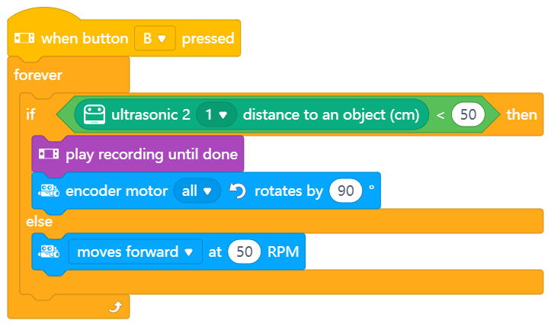

Example 2
The mBot2 drives around and plays a sound you recorded when the ambient light is low. When the mBot2 comes near an obstacle, it lets out a warning sound and turns around.

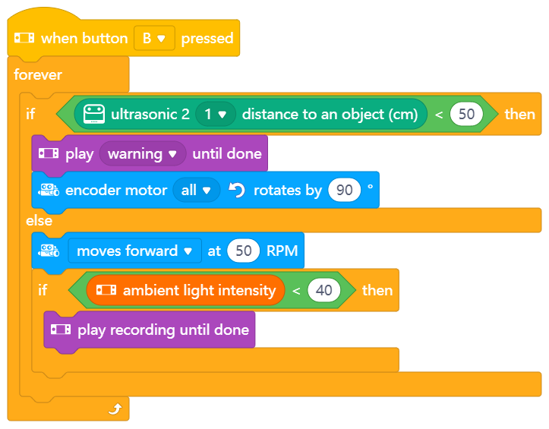

Use the knowledge you gained in 'Step 2' of this lesson. Of course, you can do plenty of experimenting yourself with the different programming possibilities in mBlock.
When thinking about this assignment, it is helpful to use the following step-by-step plan. Do you have an idea of what you want to make? If so, first discuss with your teacher whether this is feasible.

 | Explanation
Step 1: What do you want to do? | - When should the mBot2 turn around?  - What sound should the mBot2 make when it gets near an obstacle?
Step 2: What do you need? | - What do you need in addition to the mBot2?
Step 3: What code blocks do you need to make the mBot2 drive? | - How are you going to make the mBot2 drive?  - What code blocks will you use?  - Make a brief description on how your program works (pseudocode/natural language, flowchart or UML)  - If you need further explanation, you can discuss with your fellow students, the teacher, or do a research on the topic. There is help available for every coding block in mBlock as well.
Step 4: In what way do you want to show the data from the sensors on the display? | - What sound should the mBot2 make?  - What code blocks will you use?  - Make a brief description on how your program works (pseudocode/natural language, flowchart or UML)  - If you need further explanation, you can discuss with your fellow students, the teacher, or do a research on the topic. There is help available for every coding block in mBlock as well.
Step 5: Testing and implementation | - Is the first version ready? Test it! During the testing round, write down areas of improvement.  - Work on the improvement points until your mBot2 does exactly what you had in mind.  - Successful? Film the end result and ask your teacher if you can post it on social media with the hashtag #mBot2

4. Wrap up
(5 min)
Step 4: Wrap up
How did this assignment go? Did the mBot2 immediately do what you had in mind?
In this lesson, you learned how speakers work and where you encounter them in everyday life. You know how to program the CyberPi and the mBot to record via the built-in microphone and play back through the speakers. You also know how to run multiple programs independently from each other.
It is now time for a brief reflection. Think on your own and discuss with the group:
- What do you think turned out well?
- What could be better?
- Which parts of the lesson did you find easy and which did you find more difficult?
- What would you like more explanation about?
- Who could help you with that?

